MINI PROJECT 1

Date:7/10/2022

Name:Leela Jayashree.A

Trainer name: Harshee Pitroda

Course:Python

Q) You need to create a quiz game in python. The quiz needs to contain 5 questions relating to the subject python. The Quiz game asks the player questions about python. Each correct answer will score a point. At the end of the game, the program will reveal the player’s final score.

You have all freedom to create the quiz game –

* You can have the quiz game as either MCQ based with one correct answer OR you can create a quiz game where the user inputs the answer for the question
* You can give the option of “re-attempt” for the quiz
* You are free to add any more feature

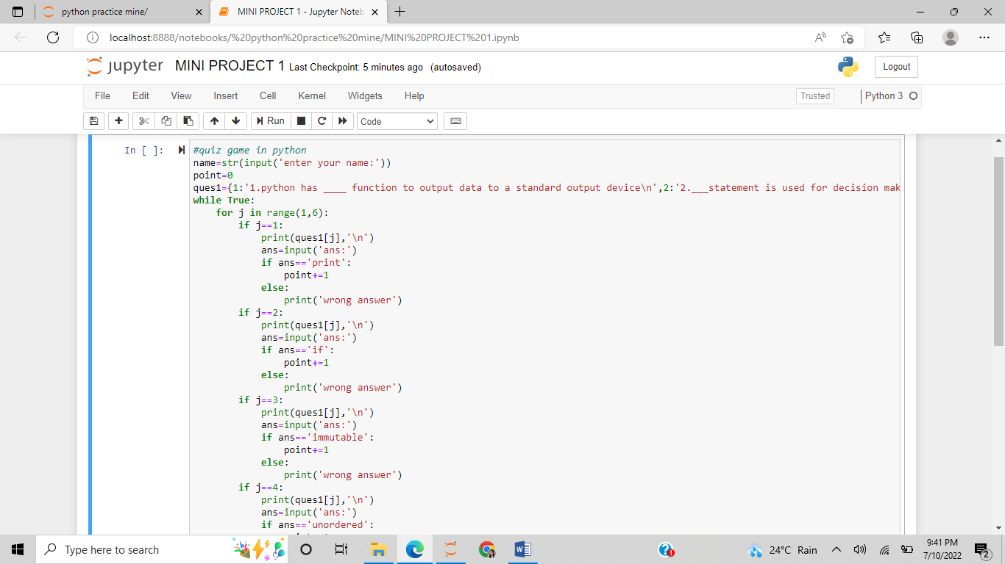

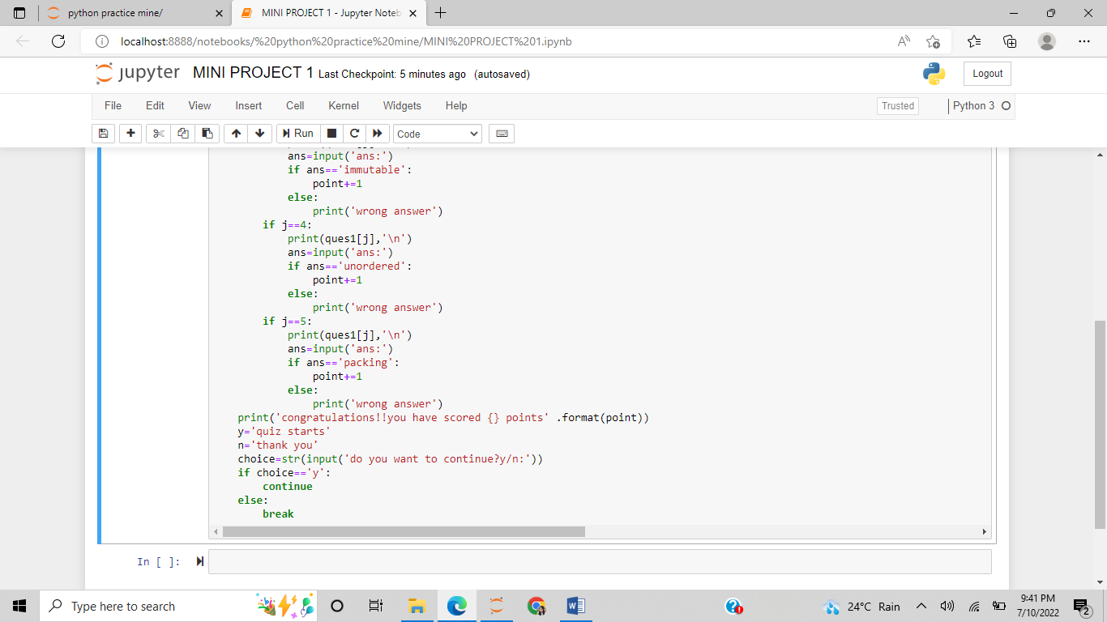

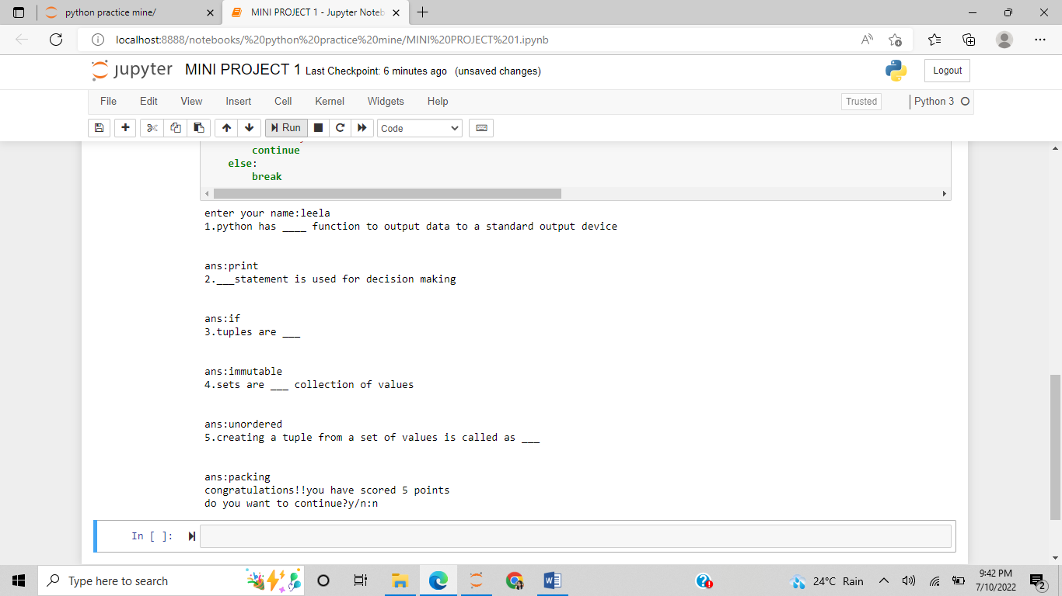

#quiz game in python

name=str(input('enter your name:'))

point=0

ques1={1:'1.python has ____ function to output data to a standard output device\n',2:'2.___statement is used for decision making\n',3:'3.tuples are ___\n',4:'4.sets are ___ collection of values\n',5:'5.creating a tuple from a set of values is called as ___\n'}

while True:

for j in range(1,6):

if j==1:

print(ques1[j],'\n')

ans=input('ans:')

if ans=='print':

point+=1

else:

print('wrong answer')

if j==2:

print(ques1[j],'\n')

ans=input('ans:')

if ans=='if':

point+=1

else:

print('wrong answer')

if j==3:

print(ques1[j],'\n')

ans=input('ans:')

if ans=='immutable':

point+=1

else:

print('wrong answer')

if j==4:

print(ques1[j],'\n')

ans=input('ans:')

if ans=='unordered':

point+=1

else:

print('wrong answer')

if j==5:

print(ques1[j],'\n')

ans=input('ans:')

if ans=='packing':

point+=1

else:

print('wrong answer')

print('congratulations!!you have scored {} points' .format(point))

y='quiz starts'

n='thank you'

choice=str(input('do you want to continue?y/n:'))

if choice=='y':

continue

else:

break